Library management system

Test Case: Borrow Restricted

TC04

**Version History**

|  |  |  |  |
| --- | --- | --- | --- |
| **Version** | **Date** | **Description** | **Author** |
| 1.0 | 1/10/2016 | Initial version | KAMAL RAJ KANDEL |

|  |  |
| --- | --- |
| **Test Case ID** | **TC04** |
| **Test Case Name** | Borrow Restricted |
| **Description** | This test case tests the process that the user is not allow to borrow the books when the restriction condition is met. It tests the following possible scenarios:   * Test if the user has borrowed more than 5 books. (TS01_01). * Test if the user has the overdue loans. (TS02_02). * Test if the user fines exceeds $10. (TS03_03). * Test if the borrower wants to borrow the book which is already borrowed by someone(TS04_04). |
| **Pre-Conditions** | User should have fine exceeding $10 or should have overdue loans or should have taken more than 5 books or should have enter the book barcode that is unavailable at this moment. |
| **Post-Conditions** | System display the message you cannot borrow at this time. |

|  |  |
| --- | --- |
| **Data Required** | |
| Member id | Positive integer from 1 to 6. |
| Book Barcode | Positive integer from 1 to 15. |

# Test script

**Version History**

|  |  |  |  |
| --- | --- | --- | --- |
| **Version** | **Date** | **Description** | **Author** |
| 1.0 | 1/10/2016 | Initial version | KAMAL RAJ KANDEL |

## The following test script were evaluated to test the Borrow Restricted test case.

## 

|  |  |
| --- | --- |
| **Test ID:** | **TS01_01** |
| **Test Name:** | Test what if the user has borrowed more than 5 books. |
| **Use Case Tested:** | Borrow books |
| **Test Description:** | Test how the system responds when the user borrowed more than 5 books. |
| **Pre-conditions:** | The user must enter the member id and must have borrowed 5 books. |
| **Post-conditions:** | System display the existing loan details and display the message you cannot borrow the book at this time. |
| **Notes:** | The member id should be correct. |
| **Result**  **(Pass/ Fail/ Warning/ Incomplete)** |  |

|  |  |  |  |  |
| --- | --- | --- | --- | --- |
| **Step Number** | **Test Step** | **Expected Test Results** | **Pass** | **Fail** |
| **1.** | User click on borrow books. | System display the card reader forum. |  |  |
| **2.** | User with member id 4 swipes the card | System display the existing loan history with a message that you cannot borrow the book at this time. |  |  |

|  |  |
| --- | --- |
| **Test Data Table** | |
| No. of test | 1 |
| For Member ID | 4 |

# 

# Result On the Screen

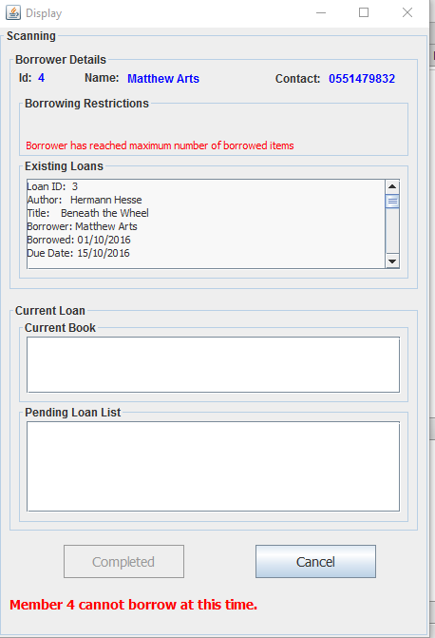

|  |  |
| --- | --- |
| **Test ID:** | **TS02_02** |
| **Test Name:** | Test what if the user has overdue loans. |
| **Use Case Tested:** | Borrow books |
| **Test Description:** | Test how the system responds when the user has the overdue loans. |
| **Pre-conditions:** | The user must enter the member id and must have overdue loans. |
| **Post-conditions:** | System display the existing loan details and display the message you cannot borrow the book at this time. |
| **Notes:** | The member id should be correct. |
| **Result**  **(Pass/ Fail/ Warning/ Incomplete)** |  |

|  |  |  |  |  |
| --- | --- | --- | --- | --- |
| **Step Number** | **Test Step** | **Expected Test Results** | **Pass** | **Fail** |
| **1.** | User click on borrow books. | System display the card reader forum. |  |  |
| **2.** | User with member id 2 swipes the card | System display the existing loan history with a message that you cannot borrow the book at this time. |  |  |

|  |  |
| --- | --- |
| **Test Data Table** | |
| No. of test | 1 |
| For Member ID | 2 |

# 

# Result On the Screen

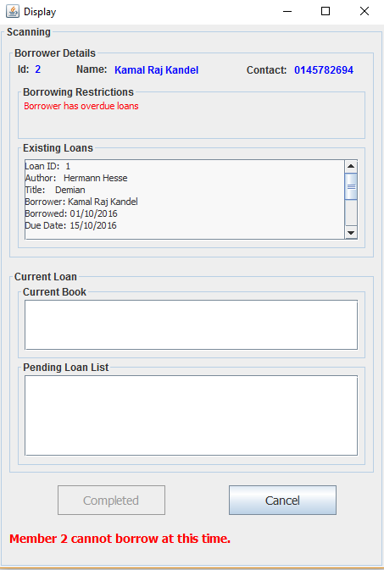

|  |  |
| --- | --- |
| **Test ID:** | **TS03_03** |
| **Test Name:** | Test what if the user has fine of 10$ or more. |
| **Use Case Tested:** | Borrow books |
| **Test Description:** | Test how the system responds when the user has fine$10 or more. |
| **Pre-conditions:** | The user must enter the member id and must have fine of at least 10$. |
| **Post-conditions:** | System display the existing loan details and display the message you cannot borrow the book at this time. |
| **Notes:** | The member id should be correct. |
| **Result**  **(Pass/ Fail/ Warning/ Incomplete)** |  |

|  |  |  |  |  |
| --- | --- | --- | --- | --- |
| **Step Number** | **Test Step** | **Expected Test Results** | **Pass** | **Fail** |
| **1.** | User click on borrow books. | System display the card reader forum. |  |  |
| **2.** | User with member id 3 swipes the card | System display the existing loan history with a message that you cannot borrow the book at this time. |  |  |

|  |  |
| --- | --- |
| **Test Data Table** | |
| No. of test | 1 |
| For Member ID | 3 |

# 

# Result On the Screen

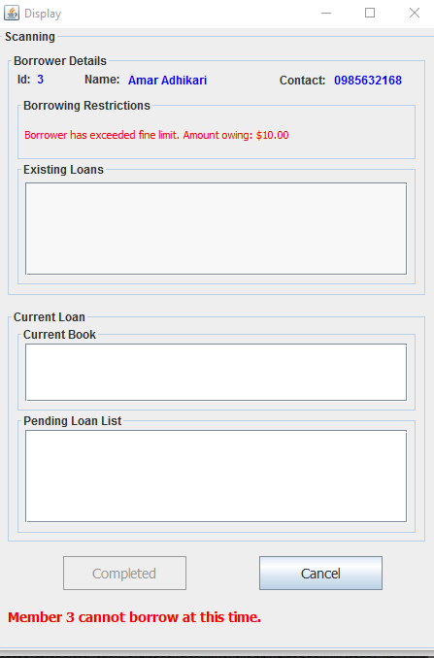

|  |  |
| --- | --- |
| **Test ID:** | **TS04_04** |
| **Test Name:** | Test if the borrower wants to borrow the book which is already borrowed by someone. |
| **Use Case Tested:** | Borrow books |
| **Test Description:** | Test how the system responds when the user wants to borrow the book which is already borrowed by someone. |
| **Pre-conditions:** | The user must enter the valid member id with no any fines, overdue or borrow limitation number with correct barcode of the book. |
| **Post-conditions:** | System display message that the book is not available. |
| **Notes:** | The member id and barcode should be correct. |
| **Result**  **(Pass/ Fail/ Warning/ Incomplete)** |  |

|  |  |  |  |  |
| --- | --- | --- | --- | --- |
| **Step Number** | **Test Step** | **Expected Test Results** | **Pass** | **Fail** |
| **1.** | User click on borrow books. | System display the card reader forum. |  |  |
| **2.** | User with member id 4 swipes the card | System activate the book scanner forum. |  |  |
| **3.** | User enter the barcode. | System display the book is not available. |  |  |

|  |  |
| --- | --- |
| **Test Data Table** | |
| No. of test | 1 |
| For Member ID | 1 |

# 

# Result On the Screen

